**Steam平台优惠信息**

**游戏：Company of Heroes 2。**链接：<https://store.steampowered.com/app/231430/Company_of_Heroes_2/?snr=1_7_7_2300_150_1>  
折扣：-95.0%，价格：¥ 3.4，前价¥ 68.0。



**游戏：Euro Truck Simulator 2 Essentials。**链接：<https://store.steampowered.com/bundle/1923/Euro_Truck_Simulator_2_Essentials/?snr=1_7_7_2300_150_1>  
折扣：-77.0%，价格：¥ 68.85，前价¥ 296.0。

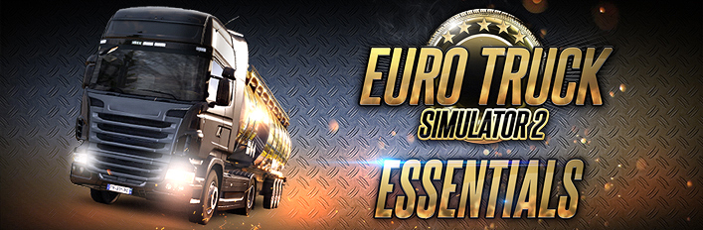

**游戏：American Truck Simulator。**链接：<https://store.steampowered.com/app/270880/American_Truck_Simulator/?snr=1_7_7_2300_150_1>  
折扣：-76.0%，价格：¥ 24.0，前价¥ 99.0。



**游戏：BioShock Infinite。**链接：<https://store.steampowered.com/app/8870/BioShock_Infinite/?snr=1_7_7_2300_150_1>  
折扣：-76.0%，价格：¥ 23.0，前价¥ 95.0。



**游戏：Euro Truck Simulator 2。**链接：<https://store.steampowered.com/app/227300/Euro_Truck_Simulator_2/?snr=1_7_7_2300_150_1>  
折扣：-76.0%，价格：¥ 24.0，前价¥ 99.0。



**游戏：Rising Storm 2: Vietnam。**链接：<https://store.steampowered.com/app/418460/Rising_Storm_2_Vietnam/?snr=1_7_7_2300_150_1>  
折扣：-76.0%，价格：¥ 19.0，前价¥ 78.0。



**游戏：The Escapists 2。**链接：<https://store.steampowered.com/app/641990/The_Escapists_2/?snr=1_7_7_2300_150_1>  
折扣：-76.0%，价格：¥ 19.0，前价¥ 78.0。

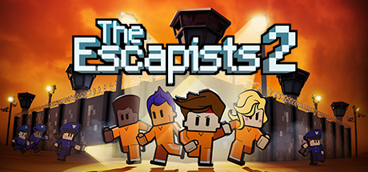

**游戏：Warhammer: Vermintide 2。**链接：<https://store.steampowered.com/app/552500/Warhammer_Vermintide_2/?snr=1_7_7_2300_150_1>  
折扣：-76.0%，价格：¥ 22.0，前价¥ 90.0。



**游戏：Resident Evil 7 Biohazard。**链接：<https://store.steampowered.com/app/418370/Resident_Evil_7_Biohazard/?snr=1_7_7_2300_150_1>  
折扣：-68.0%，价格：¥ 46.0，前价¥ 142.0。

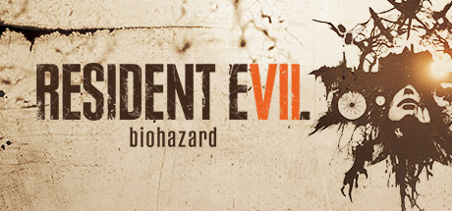

**游戏：NBA 2K21。**链接：<https://store.steampowered.com/app/1225330/NBA_2K21/?snr=1_7_7_2300_150_1>  
折扣：-67.0%，价格：¥ 65.0，前价¥ 199.0。



**游戏：Resident Evil 3。**链接：<https://store.steampowered.com/app/952060/Resident_Evil_3/?snr=1_7_7_2300_150_1>  
折扣：-67.0%，价格：¥ 136.0，前价¥ 414.0。



**游戏：【豪华版】嗜血印本体+全部服装DLC。**链接：<https://store.steampowered.com/bundle/13560/DLC/?snr=1_7_7_2300_150_1>  
折扣：-64.0%，价格：¥ 129.97，前价¥ 361.0。



**游戏：DEATH STRANDING。**链接：<https://store.steampowered.com/app/1190460/DEATH_STRANDING/?snr=1_7_7_2300_150_1>  
折扣：-60.0%，价格：¥ 119.0，前价¥ 298.0。



**游戏：Resident Evil 2。**链接：<https://store.steampowered.com/app/883710/Resident_Evil_2/?snr=1_7_7_2300_150_1>  
折扣：-60.0%，价格：¥ 87.0，前价¥ 219.0。



**游戏：No Man's Sky。**链接：<https://store.steampowered.com/app/275850/No_Mans_Sky/?snr=1_7_7_2300_150_1>  
折扣：-50.0%，价格：¥ 69.0，前价¥ 139.0。



**游戏：嗜血印 Bloody Spell。**链接：<https://store.steampowered.com/app/992300/_Bloody_Spell/?snr=1_7_7_2300_150_1>  
折扣：-50.0%，价格：¥ 29.0，前价¥ 58.0。



**游戏：Maneater。**链接：<https://store.steampowered.com/app/629820/Maneater/?snr=1_7_7_2300_150_1>  
折扣：-41.0%，价格：¥ 69.0，前价¥ 116.0。



**游戏：She Will Punish Them。**链接：<https://store.steampowered.com/app/1213740/She_Will_Punish_Them/?snr=1_7_7_2300_150_1>  
折扣：-41.0%，价格：¥ 32.0，前价¥ 54.0。

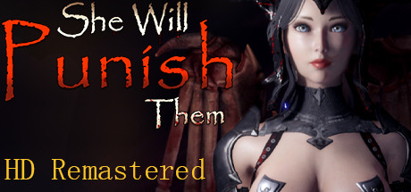

**游戏：Mafia: Definitive Edition。**链接：<https://store.steampowered.com/app/1030840/Mafia_Definitive_Edition/?snr=1_7_7_2300_150_1>  
折扣：-40.0%，价格：¥ 83.0，前价¥ 139.0。



**游戏：Neon Abyss Deluxe Edition。**链接：<https://store.steampowered.com/bundle/15860/Neon_Abyss_Deluxe_Edition/?snr=1_7_7_2300_150_1>  
折扣：-39.0%，价格：¥ 59.4，前价¥ 97.0。

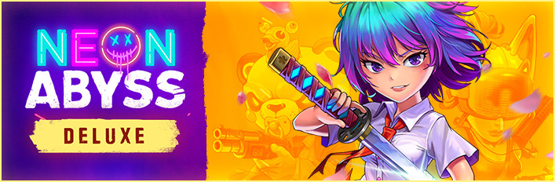

**游戏：Neon Abyss。**链接：<https://store.steampowered.com/app/788100/Neon_Abyss/?snr=1_7_7_2300_150_1>  
折扣：-34.0%，价格：¥ 38.0，前价¥ 58.0。

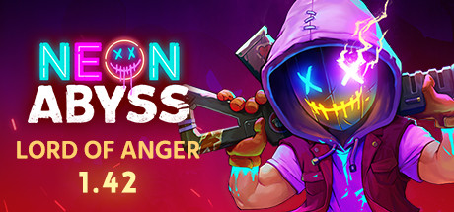

**游戏：A.D. 2047。**链接：<https://store.steampowered.com/app/1523370/AD_2047/?snr=1_7_7_2300_150_1>  
折扣：-30.0%，价格：¥ 68.6，前价¥ 98.0。

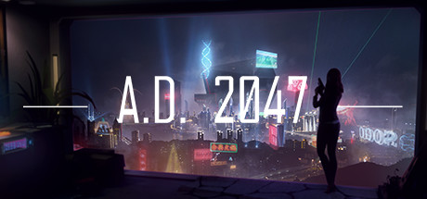

**游戏：Hell Let Loose。**链接：<https://store.steampowered.com/app/686810/Hell_Let_Loose/?snr=1_7_7_2300_150_1>  
折扣：-25.0%，价格：¥ 88.0，前价¥ 118.0。



**游戏：The Immortal Mayor。**链接：<https://store.steampowered.com/app/1426730/The_Immortal_Mayor/?snr=1_7_7_2300_150_1>  
折扣：-16.0%，价格：¥ 57.0，前价¥ 68.0。



**游戏：Dyson Sphere Program。**链接：<https://store.steampowered.com/app/1366540/Dyson_Sphere_Program/?snr=1_7_7_2300_150_1>  
折扣：-10.0%，价格：¥ 63.0，前价¥ 70.0。

